CoreLogic __________________________________

CoreLogic – Print & Ship
Integration Guide
Release 2.2

Disclaimer
The purpose of this document is to provide technical specifications to integrate with CoreLogic Print & Ship platform for document fulfillment. The information contained in this document is subject to change.

Table of Contents
Chapter 1 5
Introduction to the Integration Guide 5
Purpose 5
Conventions used in this guide 5
Production Support 6
CoreLogic Support 6
Schedule Maintenance 7
Chapter 2 8
Introduction to CoreLogic Print & Ship Integration 8
What is CoreLogic Print & Ship Integration 8
Benefits of Integration 8
Business Overview 9
Chapter 3 10
CoreLogic API Integration 10
AuthoMail API Integration 10
AuthoMail Fulfillment Callback 11
Test and Production Environments 11
CoreLogic – Authentication API 12
CoreLogic – Print & Ship API 13
Print & Ship Request: 13
Sample JSON Request 13
Data Dictionary - Request 16
Connectivity – Print & Ship Response 20
Response Code 20
Sample Success Response 20
Sample Error Response 20
Error Code 21
Sample Delivery Report Response 22
Sample Pulled Back Response 23
Data Dictionary – Response 24
CoreLogic - Print & Ship Response API: 29
Sample JSON Request 29
Response Format 29
Response Format 29
CoreLogic – Pullback API 32
Sample JSON Request 32
Pullback Response 32
Response Code 32
Pullback not requested messages 33
Sample Pullback requested Response 33
Sample Package Not Found Response 33
Sample Pullback not requested Response 34

Chapter 1

Introduction to the Integration Guide

Purpose
CoreLogic Print & Ship integration guide is a reference manual for Customers who can make print & ship request to CoreLogic and receive response with Shipping information from CoreLogic using API Integration.

Conventions used in this guide
The guide contains notes, tips and warning information to aid when using CL integration for print & ship requests.

Notes provide special information that may help you understand a concept.
Note: A note look like this

Tips have helpful information or shortcuts that may help you.
Tip: A tip look like this

Warnings offer cautionary advice to consider
Tip: A warning look like this

Production Support
CL integration for document fulfillment request is available to customers 24 hours a day 7 days a week. Production support is defined as efficient escalation, resolution of incidents identified within production environment. Production support applies to any groups that interface with CL print & ship platform. Questions or incidents may be reported by various groups including clients, vendors. General support is provided on a daily basis during regular business hours of operation.

CoreLogic Support
Regular Support Hours:
- Monday through Friday: 8:00 AM EST – 8 PM EST
- Saturday: 8:00 AM – 2 PM EST

Support Phone Number:
- Monday through Friday:
- Saturday:

CL Support: For support during standard business hours please contact the support team via email at printandshipescalation.slx@corelogic.com

Schedule Maintenance
From time-to-time CoreLogic will be unavailable due to maintenance and will notify customers accordingly.

Clients and partners will be notified in advance of any maintenance that will affect print & ship processing requests.

Technology Nomenclature
API – “application programming interface”, which is a particular set of rules or codes and specifications that allow software programs to communicate with other software programs.
DTD – “document type definitions” which are a set of rules that define the structure of an XML document.
XML – an “extensible markup language” which is a set of standardized rules for marking-up documents that can be shared on the Internet. It provides data independence.

Chapter 2

Introduction to CoreLogic Print & Ship Integration

What is CoreLogic Print & Ship Integration
CL print & ship integration is an API based integration which allows customers to seamlessly send print & ship request to CoreLogic. CoreLogic accepts any print & ship request initiated by Customers. This integration also allows CoreLogic to send the shipping details back to the customers.
The data is exchanged via request & response JSON.

Benefits of Integration

Key Benefits of Integration include:
- With a click of a button initiate print & ship request
- Send the documents to print & ship within few minutes
- Get the tracking information and shipping details the same day of print & ship request initiation.
- Seamless Reporting.
- Best User Experience
- Pull-Back Request

Business Overview
The following diagram outlines the high – level business flow of CoreLogic Print & Ship integration
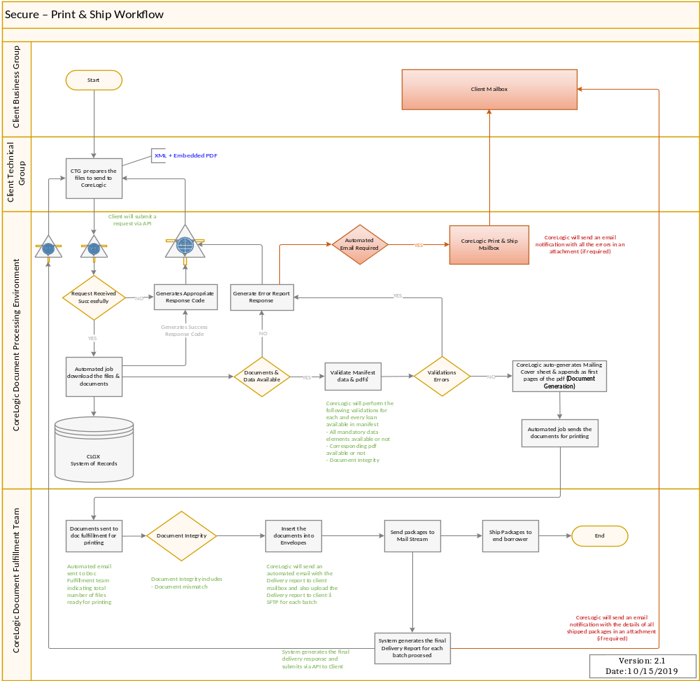

Chapter 3

CoreLogic API Integration
The following diagrams show standard way of integration with AuthoMail APIs and how AuthoMail submits delivery / errors (fulfillment) reports back to client’s endpoints.

AuthoMail API Integration
- Client posts API credentials to /token endpoint.
- The endpoint responds with a token.
- Client then includes this token in request header for all subsequent requests to an API resource (for print & ship /api/mailrequest, for pullback /api/requestpullback).
  - The token should be reused until it expires.
- API sends appropriate response to client. For example, print & ship request responds with an acknowledgement. The acknowledgement indicates whether the request was accepted / queued for further processing or rejected because of validation failures.
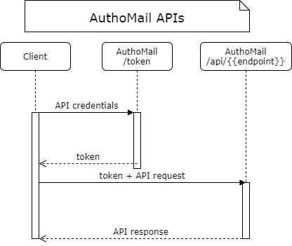
Figure 1

AuthoMail Fulfillment Callback
- AuthoMail posts API credentials to the token endpoint provided by client.
- The endpoint responds with a token.
- AuthoMail then includes this token in request header for all subsequent requests to callback API
  - The token is reused until it expires.
- Client API must acknowledge the receipt of delivery / error report. This acknowledgement marks print & ship request as complete.
The authentication scheme shown here is for illustration purposes only. Clients may use other authentication schemes. AuthoMail will make necessary changes to integrate with client specified authentication scheme.

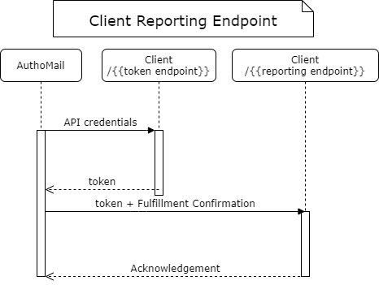
Figure 2

Test and Production Environments
The QA, Performance, Staging and Production endpoint URLs are maintained by CoreLogic and they will remain the same unless changed by CoreLogic. Here is the list of the base URLs:
Environment | Base URL | Endpoints
QA | https://authomailuat.corelogic.com | - Print & Ship Requests : /api/mailrequest  - Responses : api/mailresponse  - PullBack : /api/requestpullback
Performance | https://authomailperftest.corelogic.com
Stage | https://authomailkittest.corelogic.com
Production | https://authomail.corelogic.com

CoreLogic – Authentication API
CoreLogin Print & Ship solution uses token-based authentication. Client app POST CL provided credentials to the auth endpoint as shown in Figure 1. The endpoint responds with a token. This token should be included as HTTP Header for subsequent requests to other APIs.
Token Request Endpoint:
Request : POST https://<host>/token
Body Text : grant_type=password&username={username}&password={password}
Token Sample Response :
{
"access_token": "dsadsjreEDiOGrhd4EeqbipoxF-ImnHHnFrdJfF8cRQCxn5i8bfnElrPmEkFOdbCGPuz6pxCmsgKhLZ7cJk8BhyERUadr3h2DrUkwiOesHY0sUT6wdT-q5RVMT_4Nqf_Ld6QWjO0SR3yB-KXHjr7c0Jah_XqyBJBFG9gWQ0Ai6UBSo0EbN5u-Ehv8GH3h8bim4q3-361ZtO3peMcIyYy5Up_a6CUAEnv7FQSBzOO0x2-wZZ28Y4JCMaS-IytEhi4r6T_v1eLEK4abc4w8qyAbwSRrUn1GT_AdKWBca-Z4ot3gcAnPgE-Nck37TfuTqUk6Vi-WnEv3ulx9fUcTk7ZXz6OyThUGCARMdwNlqlXb5jtf59FSChvhZR57jRZKUoJcq4VXXsO3GMSdDJK_GiNdxkJ5QKmGLCYnTCLzjO5CIv4OBmYTHnuK1iddZA3EESFLQApGPW6bycZdKVH3iImI3w5kGK-g70OIqQ-uCD5aRcBPPMA8qLWHfoVHCEbUQLBcurlsaTXAnjOIo3ZuhvS4FULBRZhfNpU3pqa-B58YGoBemZO5Co1IlOwC26rUOObyfqSvWOVIF2iVqtiAO7ZKzI8Wn6ha135NB3i8eKko-LBT9gNDL7KL9SoSFLXReQ_RjDFh",
"token_type": "bearer",
"expires_in": 899,
"userName": "amtest",
".issued": "Tue, 17 Nov 2020 17:05:28 GMT",
".expires": "Tue, 17 Nov 2020 17:20:28 GMT"
}

Property | Comments
access_token | This is used for requesting as a Bearer key while requesting
expires_in | Expiry time in seconds
issued | Date time of token generated
expires | Date time of token when it will expire

CoreLogic – Print & Ship API
CoreLogic uses HTTP POST method for receiving the print & ship request. Request parameters must be present in HTTP headers, and the request payload must contain document metadata JSON along with actual documents. The documents and manifest JSON must be submitted as multipart/form-data request.

Print & Ship Request:
Below is the sample JSON manifest (document metadata) that needs to be submitted to CoreLogic endpoint for print & ship request.

Sample JSON Request
POST /api/mailrequest HTTP/1.1
Content Type: multipart/form-data
HTTP Headers:
Key | Value
Authorization | Bearer {access_token}
MailPieceId | 00000000-0000-0000-0000-000000000000

Request Format
{
"Id": "00000000-0000-0000-0000-000000000000",
"ClientCode": "",
"BusinessFriendlyIdName": "",
"BusinessFriendlyIdValue": "",
"DocumentOrPackageType": "",
"DocumentOrPackage": {
"Inserts": "",
"Files": [],
"Name": "",
},
"eDelivery": {
"ExpiryDate": "0001-01-01",
"IsEsign": false,
"PrintAndShipOnExpiry": false
},
"RecipientInfo": {
"Recipient": {
"Organization": "",
"Prefix": "",
"FirstName": "",
"MiddleName": "",
"LastName": "",
"Suffix": "",
"Phone": "",
"EmailAddress": ""
},
"Address": {
"OptionalLine1AboveStreet": "",
"OptionalLine2AboveStreet": "",
"Street": "",
"AptOrSuiteOrOther": "",
"OptionalLine1BelowStreet": "",
"OptionalLine2BelowStreet": "",
"City": "",
"State": "",
"Zip": "",
"Country": ""
}
},
"ReturnInfo": {
"Recipient": {
"Organization": "",
"Prefix": "",
"FirstName": "",
"MiddleName": "",
"LastName": "",
"Suffix": "",
"Phone": ""
},
"Address": {
"OptionalLine1AboveStreet": "",
"OptionalLine2AboveStreet": "",
"Street": "",
"AptOrSuiteOrOther": "",
"OptionalLine1BelowStreet": "",
"OptionalLine2BelowStreet": "",
"City": "",
"State": "",
"Zip": "",
"Country": ""
}
},
"CustomInfo": [
{
"Key": "",
"DataType": 0,
"Value": ""
}
]
}

Production loans must not be submitted in the Test Environments. Test Loans must not be submitted in the Production Environment

Data Dictionary - Request
Parameter | Data Type | Comments | Conditionality
Id | String | Globally Unique Identifier (GUID) | Required
ClientCode | String |  | Required
BusinessFriendlyIdName | String |  | Required
BusinessFriendlyIdValue | String |  | Required
DocumentOrPackageType | String |  | Required
DocumentOrPackage | Object |  | Required
eDelivery | Object |  | Optional
RecipientInfo | Object |  | Optional
ReturnInfo | Object |  | Optional
MailPieceCustomInfo | Object |  | Optional

DocumentOrPackage
Parameter | Data Type | Comments |  | Optionality
Files | List<String> | If Inserts are passed then this can be optional |  | Conditional Required
Inserts | String | If Files are passed then this can be optional |  | Conditional Required
Name | String | Optional

eDelivery
Parameter | Data Type | Comments | Optionality
ExpiryDate | Date | If E-Delivery object is passed, then ExpiryDate is required | Conditional Required
IsEsign | Boolean |  | Optional
PrintAndShipOnExpiry | Boolean | If E-Delivery object is passed, then PrintAndShipOnExpiry is required | Conditional Required

RecipientInfo
Parameter | Data Type | Comments | Optionality
Recipient | Object |  | Required
Address | Object |  | Required
ReturnInfo
Parameter | Data Type | Comments | Optionality
Recipient | Object |  | Required
Address | Object |  | Optional
Recipient
Parameter | Data Type | Comments | Optionality
Organization | String |  | Optional
Prefix | String |  | Optional
FirstName | String |  | Optional
MiddleName | String |  | Optional
LastName | String |  | Optional
Suffix | String |  | Optional
Phone | String | Regex Pattern:  ^\(?([2-9][0-8][0-9])\)?[-. ]?([2-9][0-9]{2})[-. ]?([0-9]{4})$  If ShippingMethod =  FedEx,  USPS Priority  USPS Priority Express  then Phone is required | Conditional Required
EmailAddress | String | If E-Delivery object is passed, then Recipient EmailAddress is required | Conditional Required

Address
Parameter | Data Type | Comments | Optionality
OptionalLine1AboveStreet | String |  | Optional
OptionalLine2AboveStreet | String |  | Optional
Street | String |  | Required
OptionalLine1BelowStreet | String |  | Optional
OptionalLine2BelowStreet | String |  | Optional
City | String |  | Required
State | String |  | Required
Zip | String | Regex Pattern:  ^(?(^00000(|-0000))|\d{5}(?:|[-\s]+\d{4}))$ | Required
Country | String |  | Optional

MailPieceCustomInfo
Parameter | Data Type | Comments | Optionality
Key | String | If MailPieceCustomInfo object is passed, then Key is required | Conditional Required
DataType | String | If MailPieceCustomInfo object is passed, then DataType is required  Allowable Values:  - String  - DateTime  - Boolean  - Integer  - Float | Conditional Required
Value | String | If MailPieceCustomInfo object is passed, then Value is required | Conditional Required

In order to get the request successfully processed, the request xml should be sent as per agreed specifications.

Connectivity – Print & Ship Response
All response bodies are JSON-formatted with "Content-Type: application/json"
Below is the sample example of a response JSON that will be triggered by CoreLogic for print & ship response to Client EndPoint URL.

Response Code
Condition | Code
200 | Success
400 | Most Failures
401 | Auth Failure
500 | Misc. Server Issues or Service Unavailable
406 | Previous instance of the request is being processed or Incomplete request
409 | Duplicate Request (the “Id” field is used to check uniqueness)
413 | Request size is above limits

Sample Success Response
{
"UniqueId": "00000000-0000-0000-0000-000000000000",
"MailingStatus": "Acknowledgement",
"Message": "Your request is queued for processing."
}

Sample Error Response
{
"Id": "00000000-0000-0000-0000-000000000000",
"ReceivedOn": "0001-01-01T00:00:00",
"ClientCode": "",
"BusinessFriendlyIdName": "",
"BusinessFriendlyIdValue": "",
"DocumentOrPackageType": "",
"DocumentOrPackage": {
"Name": ""
},
"RecipientInfo": {
"Recipient": {
"FirstName": "",
"LastName": ""
},
"Address": {
"Street": "",
"City": "",
"State": "",
"Zip": ""
}
},
“MailingStatus”: "Error",
"ErrorCode": "Mailing_Address_Missing_Or_Invalid",
"ErrorDesc": "Mailing_Address_Missing_Or_Invalid"
}

Error Code
Mailing_Address_Missing_Or_Invalid
Recipient_Details_Missing_Or_Invalid
Unknown_Error
Invalid_PackageType
Invalid_ShippingDetail
Invalid_DuplicateKey
Invalid_PDF_File
Missing_PDF_File
Issue_In_EDelivery
SigningRoomExpired
Invalid_MailPieceId
NotAcceptable
MaxRetriesExceeded
RequestTooLarge
Manifest_Missing_Or_Invalid
Invalid_ClientCode
Missing_DocumentOrPackage
Missing_Files

Sample Delivery Report Response
{
"Id": "00000000-0000-0000-0000-000000000000",
"ReceivedOn": "0001-01-01T00:00:00",
"ClientCode": "",
"BusinessFriendlyIdName": "",
"BusinessFriendlyIdValue": "",
"DocumentOrPackageType": "",
"DocumentOrPackage": {
"Name": ""
},
"RecipientInfo": {
"Recipient": {
"FirstName": "",
"LastName": ""
},
"Address": {
"Street": "",
"City": "",
"State": "",
"Zip": ""
}
},
“MailingStatus”: "Shipped",
"ShippedOn": "0001-01-01T00:00:00",
"ShippingMethod": "USPS",
"ShippingServiceType": "PRIORITY",
"TrackingNumber": 0,
"TotalPages": 0,
"TotalSheets": 0
}

Sample Pulled Back Response
{
"Id": "00000000-0000-0000-0000-000000000000",
"ReceivedOn": "0001-01-01T00:00:00",
"ClientCode": "",
"BusinessFriendlyIdName": "",
"BusinessFriendlyIdValue": "",
"DocumentOrPackageType": "",
"DocumentOrPackage": {
"Name": ""
},
"RecipientInfo": {
"Recipient": {
"FirstName": "",
"LastName": ""
},
"Address": {
"Street": "",
"City": "",
"State": "",
"Zip": ""
}
},
“MailingStatus”: "PulledBack",
"PulledBackOn": "0001-01-01T00:00:00"
}

Data Dictionary – Response
Parameter | Data Type | Comments | Conditionality
Id | String | Globally Unique Identifier (GUID) | Required
ReceivedOn | DateTime
ClientCode | String |  | Required
BusinessFriendlyIdName | String |  | Optional
BusinessFriendlyIdValue | String |  | Optional
DocumentOrPackageType | String |  | Optional
DocumentOrPackage | Object |  | Optional
RecipientInfo | Object |  | Optional
MailingStatus | String | Allowable Value: | Required
  Verifying | Request is still being processed by the endpoint.
  Queued | Request passes all initial verifications and is now queued for our print services.
  InProgress | Request is now picked up for further processing by our print services.
  Shipped | Request is fulfilled.
  Error | Manifest validation errors, Decryption errors, PDF errors, etc.
  PulledBack | Package is pulled out of the workstream as requested.
ShippedOn | Date | Only Required If Mailing Status = SHIPPED | Conditional Required
ShippingMethod | String | Only Required If Mailing Status = SHIPPED | Conditional Required
ShippingServiceType | String | Only Required If Mailing Status = SHIPPED | Conditional Required
TrackingNumber | String | Only Required If Mailing Status = SHIPPED | Conditional Required
TotalPages | Integer | Only Required If Mailing Status = SHIPPED | Conditional Required
TotalSheets | Integer | Only Required If Mailing Status = SHIPPED | Conditional Required
Postage | Decimal |  | Optional
PulledBackOn | DateTime | Only Required If Mailing Status = PulledBack | Conditional Required
ErrorCode | String | Only Required If Mailing Status = Error | Conditional Required
ErrorDesc | String | Only Required If Mailing Status = Error | Conditional Required

RecipientInfo
Parameter | Data Type | Comments | Required
Recipient | Object |  | Required
Address | Object |  | Required

Recipient
Parameter | Data Type | Comments | Optionality
Organization | String |  | Optional
Prefix | String |  | Optional
FirstName | String |  | Optional
MiddleName | String |  | Optional
LastName | String |  | Optional
Suffix | String |  | Optional
Phone | String | Regex Pattern  ^\(?([2-9][0-8][0-9])\)?[-. ]?([2-9][0-9]{2})[-. ]?([0-9]{4})$ | Optional
EmailAddress | String | Not for ReturnInfo | Optional

DocumentOrPackage
Parameter | Data Type | Comments | Optionality
Name | String |  | Optional

Address
Parameter | Data Type | Implementation Notes | Optionality
OptionalLine1AboveStreet | String |  | Optional
OptionalLine2AboveStreet | String |  | Optional
Street | String |  | Optional
OptionalLine1BelowStreet | String |  | Optional
OptionalLine2BelowStreet | String |  | Optional
City | String |  | Optional
State | String |  | Optional
Zip | String | Regex Pattern:  ^(?(^00000(|-0000))|\d{5}(?:|[-\s]+\d{4}))$ | Optional
Country | String |  | Optional

CoreLogic - Print & Ship Response API:
Below is the sample JSON manifest (document metadata) that needs to be submitted to CoreLogic endpoint for print & ship response.

Sample JSON Request
GET /api/mailresponse HTTP/1.1
Params: mailPieceIds={comma separated ids}
Content Type: application/json
HTTP Headers:
Key | Value
Authorization | Bearer {token}

Response Format
/api/mailresponse?mailPieceIds={comma separated ids}
Example:
/api/mailresponse?mailPieceIds=00000000-0000-0000-0000-000000000000, 00000000-0000-0000-0000-000000000000

Response Format
All response bodies are JSON-formatted with "Content-Type: application/json"
Below is the sample example of a response.

Sample Response
[
{
"Id": "00000000-0000-0000-0000-000000000000",
"ReceivedOn": "0001-01-01T00:00:00",
"ClientCode": "",
"BusinessFriendlyIdName": "",
"BusinessFriendlyIdValue": "",
"DocumentOrPackageType": "",
"DocumentOrPackage": {
"Name": ""
},
"RecipientInfo": {
"Recipient": {
"FirstName": "",
"LastName": ""
},
"Address": {
"Street": "",
"City": "",
"State": "",
"Zip": ""
}
},
"MailingStatus": "Error",
"ErrorCode": "Mailing_Address_Missing_Or_Invalid",
"ErrorDesc": "Mailing_Address_Missing_Or_Invalid"
} ,
{
"Id": "00000000-0000-0000-0000-000000000000",
"ReceivedOn": "0001-01-01T00:00:00",
"ClientCode": "",
"BusinessFriendlyIdName": "",
"BusinessFriendlyIdValue": "",
"DocumentOrPackageType": "",
"DocumentOrPackage": {
"Name": ""
},
"RecipientInfo": {
"Recipient": {
"FirstName": "",
"LastName": ""
},
"Address": {
"Street": "",
"City": "",
"State": "",
"Zip": ""
}
},
"MailingStatus": "Shipped",
"ShippedOn": "0001-01-01T00:00:00",
"ShippingMethod": "",
"ShippingServiceType": "",
"TrackingNumber": "",
"TotalPages": 0,
"TotalSheets": 0
}
]

CoreLogic – Pullback API
The pullback API allows client applications to “request” pullback for specific package(s). Once a print & ship request is submitted, it can be anywhere in the process cycle. Depending on the current status, it may or may not be possible to execute pullback. Consider the following scenarios:
- If a package is being processed by our job and yet to be submitted to our print team, pullback request should succeed within minutes.
- If a package is delivered to print team for fulfillment, it must be manually aborted. In this case, pullback request should succeed but it will take longer to receive confirmation on pullback.
- If a package is picked up by courier company, pullback is not entertained.
The outcome of pullback request is submitted with delivery report. If it succeeds, MailingStatus is reported as "PulledBack", otherwise, it is either “Shipped” or “Error”.

Sample JSON Request
POST /api/requestpullback HTTP/1.1
Content Type: application/json
HTTP Headers:
Key | Value
Authorization | Bearer {token}

Request Format
[ Arrayof MailPieceIds ]
Example:
["00000000-0000-0000-0000-000000000000", "00000000-0000-0000-0000-000000000000"]

Pullback Response
All response bodies are JSON-formatted with "Content-Type: application/json"
Below is the sample example of a response.

Response Code
Condition | Code
Success | 200
Most Failures | 400
Auth Failure | 401
Misc. Server Issues | 500

Pullback not requested messages
Mailpiece has an error, it is not going to be printed. Check error report for details.
Pullback is already requested for this mailpiece.
Mailpiece is already pulled back.
Mailpiece is already shipped, pullback cannot be requested.
Mailpiece is already EDelivered, pullback cannot be requested.
The requested mailpiece is yet to be received or validated.
Invitation for signing room is already sent to Borrower, pullback cannot be requested.

Sample Pullback requested Response
{
"MailPieceId": "00000000-0000-0000-0000-000000000000",
"Message": "Pullback request is recorded successfully.",
"PullBackRequestedOn": "0001-01-01T00:00:00",
"PulledBackRequestedBy": "",
"MailingStatus": ""
}

Sample Package Not Found Response
{
"MailPieceId": "00000000-0000-0000-0000-000000000000",
"Message": "The requested mailpiece is yet to be received or validated ",
"MailingStatus": "NotFound"
}

Sample Pullback not requested Response

{
"MailPieceId": "00000000-0000-0000-0000-000000000000",
"Message": "Mailpiece has an error, it is not going to be printed. Check error description for details.",
"MailingStatus": "Error",
"ErrorDescription": "Pdf file is not provided in package."
}

